Supporting data for paper <https://doi.org/10.1002/cvde.201507191>

Erratum to

**Numerical modeling of the droplet vaporization for design and operation of**

**liquid pulsed CVD**

The paper presented the modeling for non-steady evaporation processes of liquid solution droplets injected into a pumped-down low-pressure vessel having a specified wall temperature. Numerical simulations were carried out for one of the few precursors with sufficient physical property data, TTIP. We compared the droplet evaporation processes for two possible solvents, toluene and hexane. Unfortunately, a discrepancy in the unit systems of the property references (molar units vs mass units) was not detected during the modeling used in this paper. We present here the correct property values, the corrected figures and updated discussion. The sensitivity analysis and stages of the vaporization process elicited in the simulations are not affected by this error. Updated figures 5, 6, 7, 10 and 11 showing corrected droplet evaporation times for a process, normalized to 10 s cycles, are given in this Erratum.

The correct enthalpy of vaporization for TTIP is ΔHvap = 219.2 kJ/kg (instead of 62.3 kJ/kg) and for toluene ΔHvap = 401.6 kJ/kg (instead of 38.1 kJ/kg). In consequence, the vaporization times for TTIP and toluene mixtures were underestimated. The vaporization time of a mixture of TTIP and hexane is 3.81 s (instead of 2.35 s). The vaporization time of a mixture of TTIP and toluene is 4.68 s (instead of 1.89 s).

The main consequence of the unit error is the discussion in section 3.2 where we use the model results to consider the choice of solvent. In MOCVD it is sometimes possible to choose between chemically compatible solvents for a given precursor. The main motivation for this study was to understand how the physical properties of vapor pressure, specific heat and enthalpy of vaporization might influence the precursor vaporization. We have many years of experience with toluene, but have not yet tried hexane as a vaporization solvent for TTIP. There is no reported experimental comparison in the literature. Hexane has six times higher vapor pressure than toluene, so one might conclude that hexane would be a vastly superior choice. However in our recently reported preliminary study of pp-MOCVD alumina deposition using different precursors and solvents, we did not get markedly different results due to solvent alone [16]. The erroneous shorter drop life for toluene seemed to possibly fit with one aspect of our previous results, but this could definitely be due to one of many other factors like solvent and precursor chemistry and variability of working conditions.

The model shows how vaporization kinetics are mainly controlled by enthalpy of vaporization, not vapor pressure. Toluene and hexane have similar enthalpy of vaporization. This aspect of the mathematical description of the problem, the study with pure hexane, the sensitivity analysis and the rules of optimization for pressure-pulsed CVD process do not suffer any inaccuracy, according to our simplifying assumptions. We confirm that a solvent and precursor with high vapor pressure and low enthalpy of vaporization should be chosen and that the main processing parameter to control is the reactor wall temperature, which provides heat for phase change and shortens droplet life. We plan to carry out experimental work in the near future with TTIP using different solvents and with different reactor wall temperature to study the effects on vaporization efficiency and thus growth rate.

**Corrected Figures**

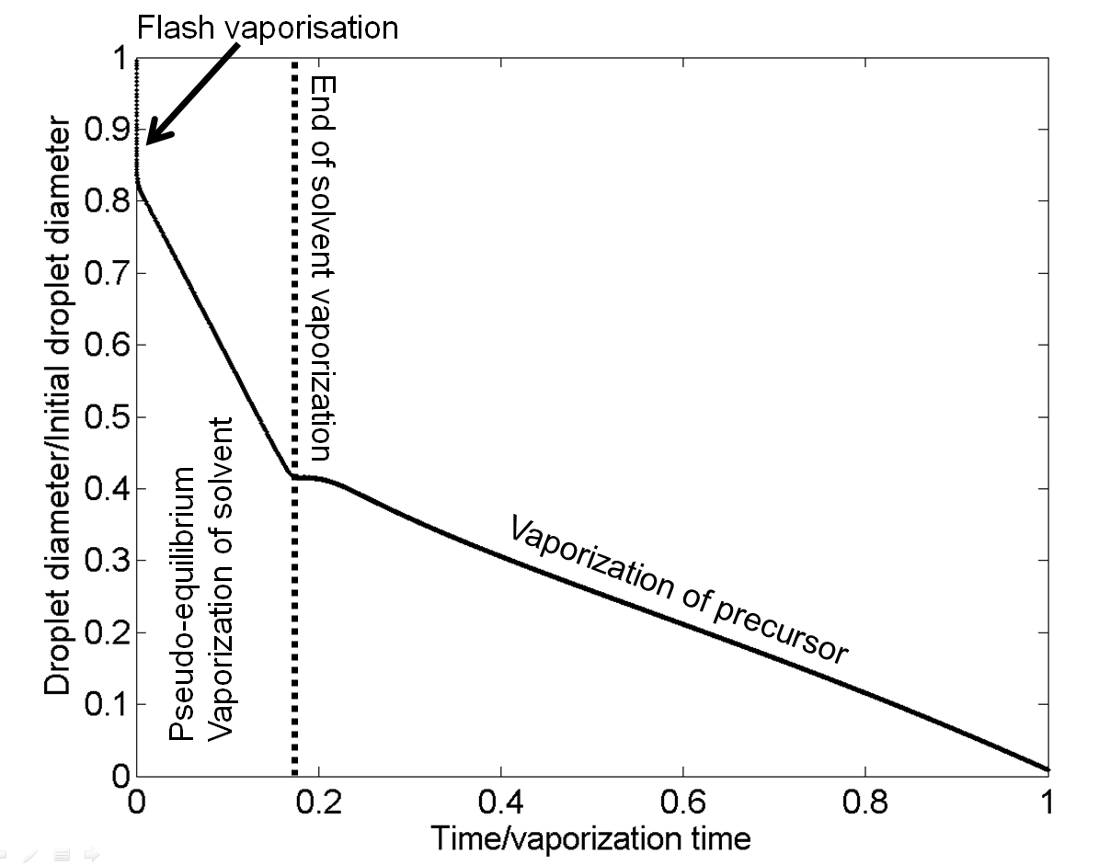

*Figure 5: droplet diameter versus reduced time with 10:1 hexane/TTIP mixture*

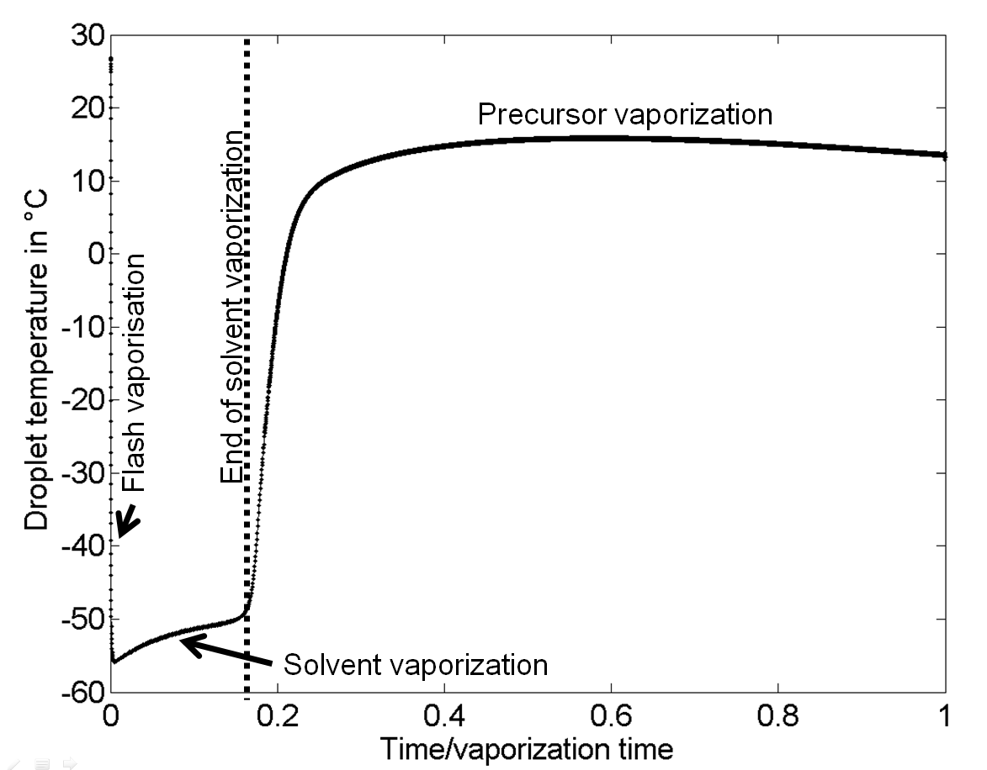

*Figure 6: droplet temperature versus reduced time with 10:1 hexane/TTIP mixture*

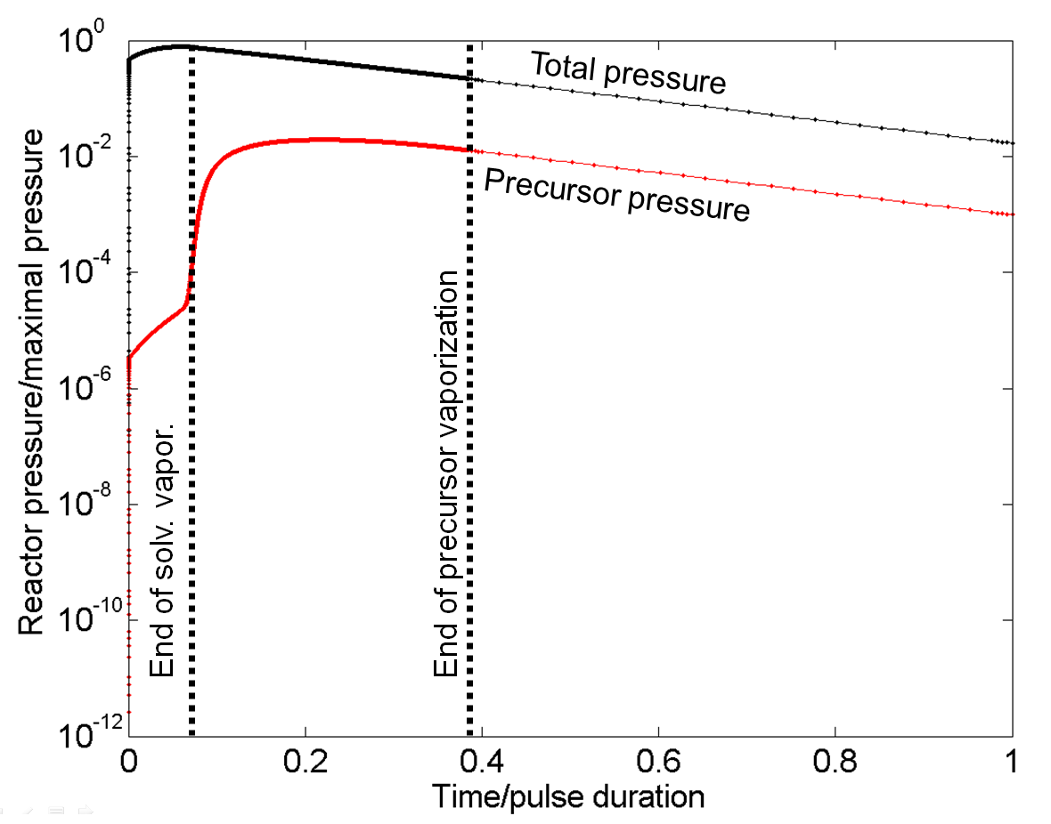

*Figure 7: reactor pressure versus reduced time with 10:1 hexane/TTIP mixture.*

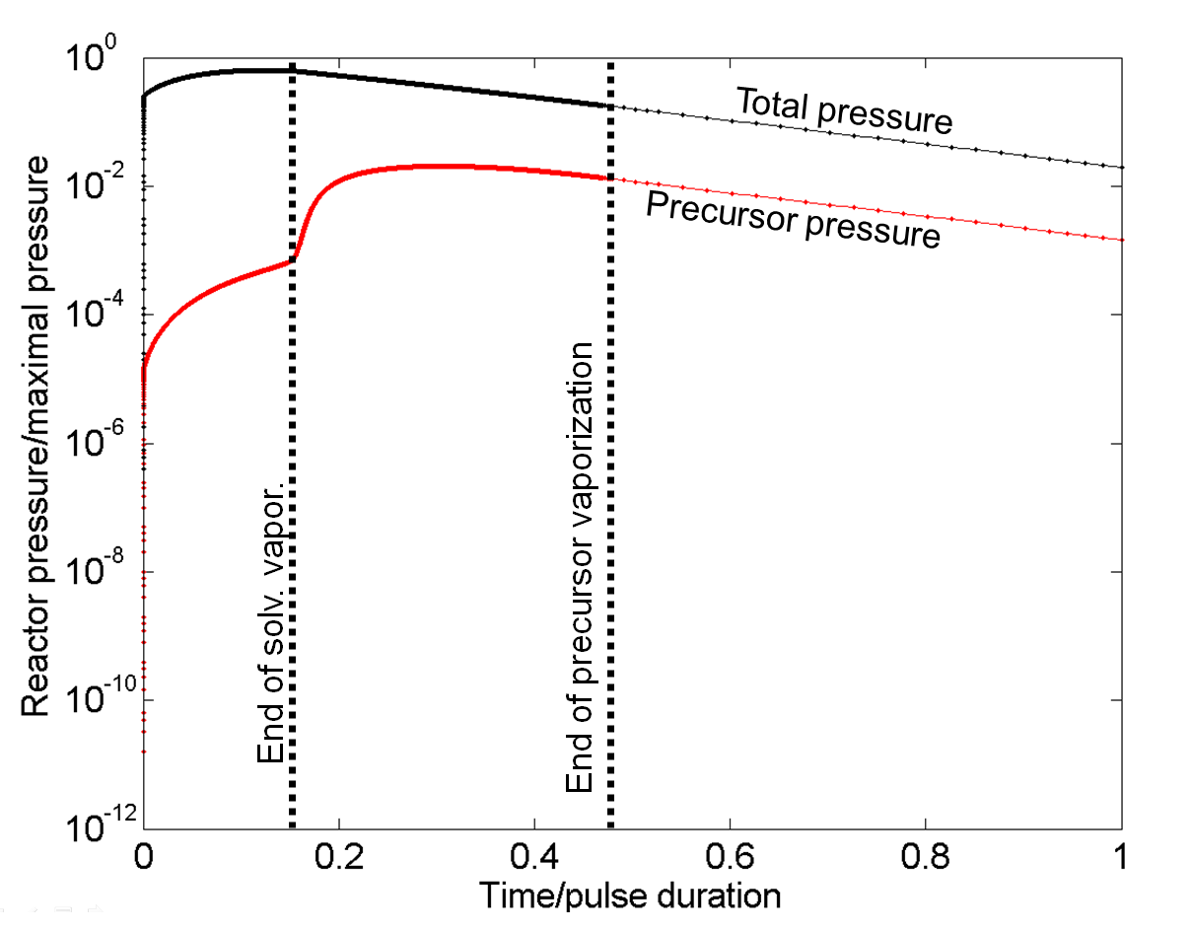

*Figure 10: reactor pressure versus reduced time with 10:1 toluene/TTIP mixture.*

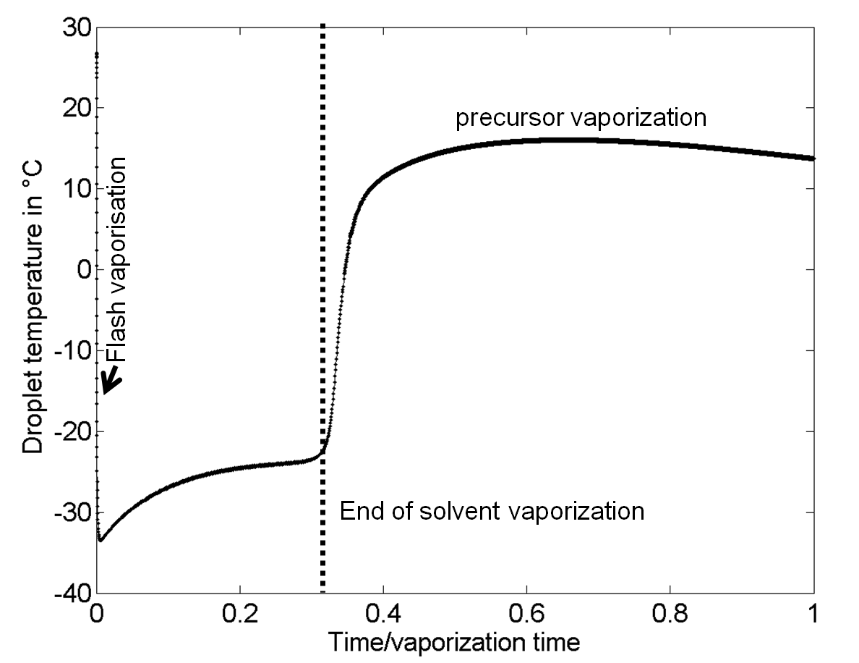

Figure 11: *droplet temperature versus reduced time with 10:1 toluene/TTIP mixture.*